In this project, we will be building a chatbot using Watson assistant. This chat contains the following capabilities:

Login to the IBM Account

Create Watson Assistant Services and Launch the Service

Create Intents, Entities and Dialogs as per the requirements of the Movie Ticket BOT.

**Intents:**

     Greetings

     Book Tickets

     Enquiry

     Movies

**Entities:**

  greetings

  booktickets

  email

  enquiry

  movieslist

  payment

  rate

**Dialogs:**

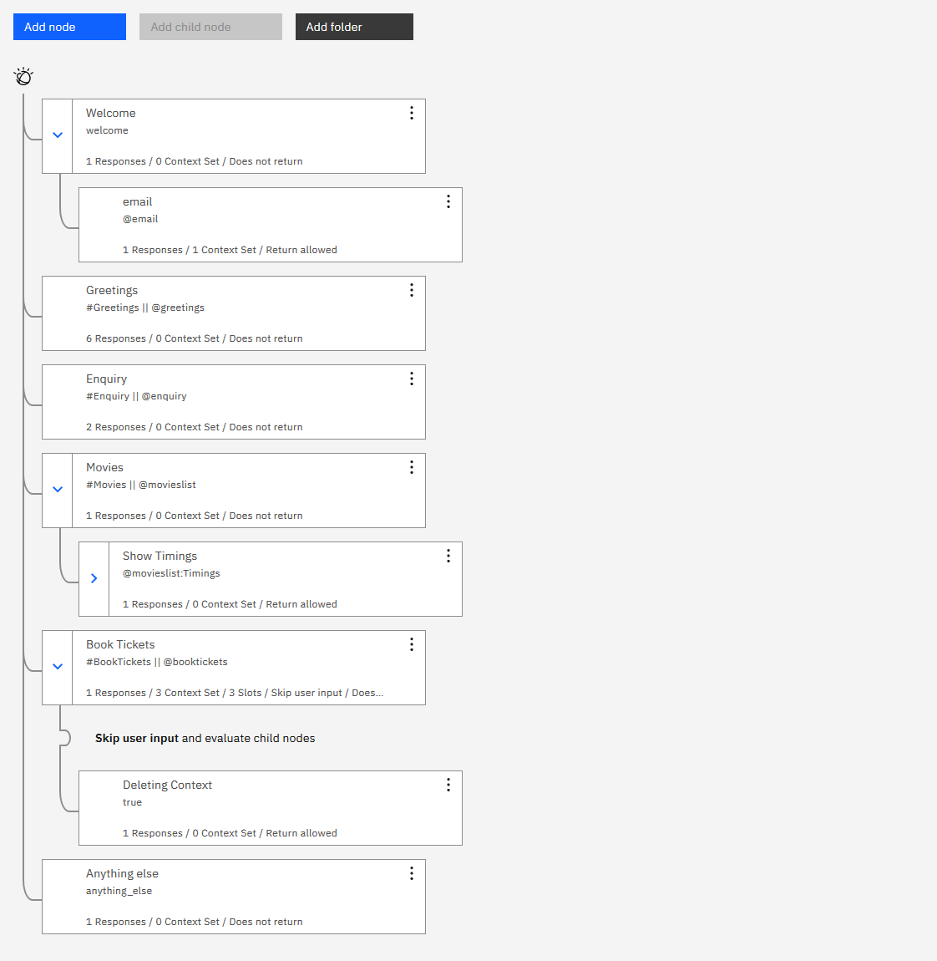

Its lists out the Movies available in a Mall.

The Bot Will show different show timings

When a movie is selected, the bot will show the availability of tickets and their respective prices.

The bot will also book the tickets.